Calculating a link budget

Date: 24-09-2018  
Author(s): Rafał Grasman, Bas Woudstra

Contents

Link Budget 2

Question 1 2

Question 2 2

References 3

# Link Budget

## Question 1

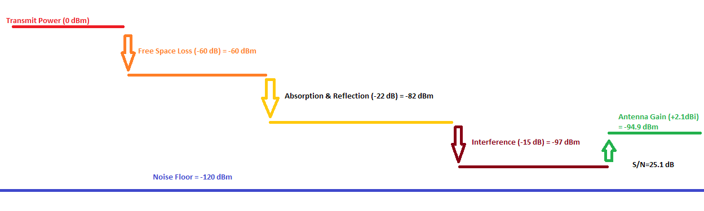1mW = 0 dBm

Receiver sensitivity is -92 dBm, which is not enough because signal is -94.9 dBm (which is below -92 dBm), so meaningful communication will probably be not possible.

## Question 2

If a directional antenna were used then if the antenna’s would be pointed to each other, the gain would be greater than 2.1 dBi, if the gain would be greater than 5 dBi then the devices may possible be able to communicate. A con would be that the antenna’s need to face each other because in all other non-focused directions the signal strength is at a loss instead of a gain.1

## Question 3

Because ZigBee’s are low-power devices they can be easily jammed by broadcasting a much stronger signal on the 2.4 GHz band.2 The whole band of 100 MHz should be attenuated and random garbled data make meaningful communication impossible if the power is significantly higher than the Zigbee transmission power. This means that, calculating back from the link budget, the attacker should have a transmission power of at least 3 dBm (1mW + 1 mW = 2mW = 3 dBm) to be “louder” than both devices combined. Without antenna gain this should be at least 5.1 dBm which corresponds to 3.2 mW.

# References

1. Directional Antenna. (n.d.). Retrieved September 25, 2018, from [hhttps://en.wikipedia.org/wiki/Directional_antenna](https://en.wikipedia.org/wiki/Radio_wave)
2. Zillner, T. (2015). ZIGBEE EXPLOITED - The good, the bad and the ugly. Retrieved September 25, 2018, from <https://www.blackhat.com/docs/us-15/materials/us-15-Zillner-ZigBee-Exploited-The-Good-The-Bad-And-The-Ugly-wp.pdf>